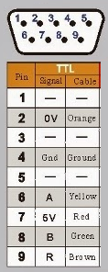DRI-Light

8-digit LED-display Connector

|  |  |  |  |  |
| --- | --- | --- | --- | --- |
| GND | DIO | RCLK | SCLK | VCC |
| **GND** | **SSIxTx** | **SSIxFss** | **SSIxClk** | **3V3** |

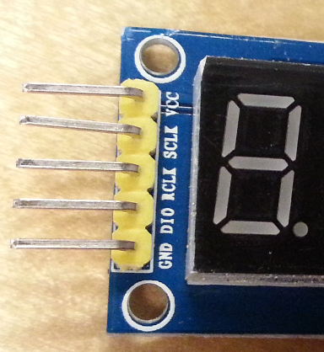

9-pin Linear Scale Connector

|  |  |
| --- | --- |
| Pin | Signal |
| 1 | n. u. |
| 2 | **GND** |
| 3 | n. u. |
| 4 | Shield |
| 5 | n. u. |
| 6 | **PhAx** |
| 7 | **5V** |
| 8 | **PhBx** |
| 9 | **IDXx** |

LaunchPad Connections

|  |  |  |  |  |  |  |  |  |
| --- | --- | --- | --- | --- | --- | --- | --- | --- |
|  |  |  |  |  |  |  |  |  |
| 3V3 | **1.01** | **3.01** | 5V |  | SSI1Clk | 4.01 | **2.01** | GND |
|  | 1.02 | **3.02** | GND |  | SSI1Fss | 4.02 | 2.02 |  |
| n. u. | 1.03 | 3.03 | SSI3Clk |  | Button1 | 4.03 | 2.03 |  |
| n. u. | 1.04 | 3.04 | SSI3Fss |  | IDX1 | 4.04 | 2.04 | (*) |
| n. u. | 1.05 | 3.05 | (*) |  | PhA1 | 4.05 | 2.05 | Reset |
|  | 1.06 | 3.06 | SSI3Tx |  | PhB1 | 4.06 | 2.06 |  |
|  | 1.07 | 3.07 | n. u. |  | Button0 | 4.07 | 2.07 |  |
|  | 1.08 | 3.08 | n. u. |  | PhA0 | 4.08 | 2.08 |  |
|  | 1.09 | 3.09 | n. u. |  | PhB0 | 4.09 | 2.09 |  |
|  | 1.10 | 3.10 | SSI1Tx |  | IDX0 | 4.10 | 2.10 |  |
|  |  |  |  |  |  |  |  |  |

**Note: Remove R9 and R10 from the LaunchPad!**